**What is the role of networks and platforms in the European culture field?**

http://www.forum-avignon.org/en/what-role-networks-and-platforms-european-culture-field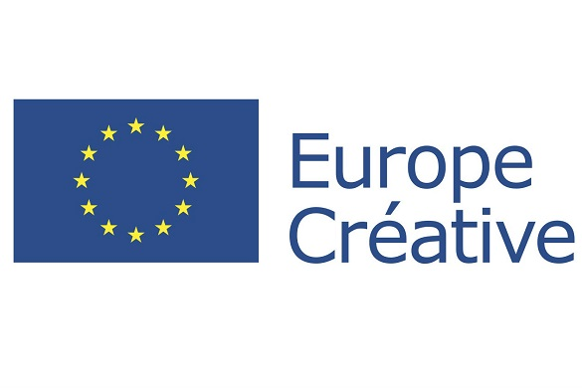



***By Mario d’Angelo (Professor at ESC Dijon Bourgogne) and Paul Vespérini (consultant at Idée Europe)***

What is the place of networks and platforms in the culture field (including creative industries) both in European culture politics and co-operation policies?

This development is happening even as the European Union is launching its new program “Creative Europe” in which it will indeed to strengthen “established” networks and platforms (i.e. with legal forms) representing different activities or different professions (including creators, artists, experts, policy makers etc.) or different issues. Questions concerning “culture and power” necessarily include an examination of the different aspects of networks in the European culture field.

Action theory and policy making theories have analyzed networks as being appropriate forms which correspond to the growing complexity of post-modern societies. Several features have been pointed out among which:

* The networks’ specific management patterns: non-hierarchic based forms, building and enhancement of a large range of skills (communication, sharing experience, innovation), a co-operation and exchange-oriented framework, facilitation of staff mobility within the membership network)**[1]**;
* The intermediation role networks have in public governance, between on the one hand, the European authorities having to decide far from grassroots issues and on the other hand, numerous culture organizations and professionals having common issues and needs.

The significant expansion of established networks ever since its pioneering times at the end of the 70s**[2]** is not surprising. Networks have become a relevant form both in working methods, which are visible in the entire culture sector, and in representing common interests of specific activities or issues. Nowadays, interaction between European institutions and established networks has become a cornerstone for co-operation and exchanges in the culture field as well as for policy making at the European level.

A network can gather organizations operating in an identified activity like European Broadcasting Union or represent very specific activities or issues (e.g. multidisciplinary cultural centers in regenerated sites like Trans Europe Halles). Some networks gathering local authorities with broader aims are invested in culture (e.g. ENTP, the European New Towns Platform, which is involved in projects dealing with culture and development).

* Although networks are used differently they have at least three common points: advocacy missions, funding needs and governance challenges.If some of the networks and platforms are obviously focused on lobbying activities (like Culture Action Europe or European Music Office), more often the networks have to reconcile an advocacy mission and a set of in-house activities so that their members feel membership utility (provide good information and exchange, co-operation in sharing experience etc.). Under no circumstances, a network can be only focused on advocacy. However, a network cannot only remain focused on a networking purpose since the network has to be recognized by the authorities and therefore necessarily remain visible in its institutional environment. Advocacy missions and membership activities in such structures are very close concepts so that often one cannot go without the other.
* A Network’s financial balance is linked to three types of incomes: membership dues and internal services paid by the members, subsidies coming from the European institutions, states and public authorities, and commissioned works (most often coming from European bodies). The two latter types of financings are directly linked to networks being recognized as having a social utility and having an important position as intermediaries. However, despite the importance of ICT in network operating, face to face professional meetings and events are indispensable in the networking form itself, and being visible is required by the authorities. This double obligation brings about additional costs. Having for the most part adopted the non-profit association status[3], networks must increasingly look for sponsors, donors or partnerships with other bodies, even other networks, to get complementary funding or to share costs.
* Size understanding, as the number of members increases or decreases, can be an important challenge for a network either as a source of strength or weakness. For instance, a network such as IETM (International network for contemporary performing arts) gathering more than 550 theaters and dance companies throughout Europe and beyond). Many of its members are small-sized operations and can only pay low membership dues, and, if the network is not granted to them, they can only be weakly involved in its activities on an international level (professional meetings, training sessions, workshops, etc.). Generally speaking, a network’s legitimacy depends on its capacity to represent a profession or an activity in its entirety, so as to be able to gather and include small-sized organizations. In addition to its activities and membership size, the operation of a network itself may require a staff. These operational issues can be compared to those of a company having to operate on an international level. Likewise, the growth and size of a network may lead to questioning its management on issues such as the real power of the board, staff requirements or managing the size, growth and implementation of activities on a larger scale.

To conclude, one could say that the networks have to achieve their expected missions mostly through two critical success factors:

* Long term recognition by public authorities at each of the four levels (towns, regions, states, Europe) whose funding is needed to organize for instance meetings and events;
* Membership utility recognition: such as developing frameworks, bringing information exchange, sharing experience, participation in co-operation projects with added value to the members, possibilities of mobility.

**References**

Deru, J-P. (2011), *Development of Cultural Networks in Europe: Challenges and Trends*, available on: <http://www.culturecongress.eu/ngo/ngo_bestpractice_deru>

D’Angelo, M. (2013), *Gouvernance et politiques culturelles en Europe*, Paris, collection Innovations et Développement n°11, éditions Idée Europe, available on: <http://idee-europe.eu/publications/>

ERICarts Institute (2008), *Mobility Matters: Programmes and Schemes to Support the Mobility of Artists and Cultural Professionals in Europe*, Study for the European Commission.

Tims, C., Shelagh, W. (2013), *The Invisible Hand. Art in the transition to another economy*, available on <http://ietm.org/sites/default/files/invisible_hand_0.pdf>

Young, L., Everitt, J. (2004), Advocacy Groups, Vancouver (BC), University of British Columbia Press.

**Links**

Creative Europe: <http://ec.europa.eu/culture/creative-europe/video-interviews_en.htm>

Culture Action Europe : <http://www.cultureactioneurope.org/>

European Office Music: EMO: <http://www.emo.org/onair_news.php>

European Broadcasting Union (EBU): [http://www3.ebu.ch](http://www3.ebu.ch/)

ENTP (European New Towns and Pilot Cities Platform): <http://www.pilotcities.eu/>

Eurocities: <http://www.eurocities.eu/>

ICOMOS (International Council on Monuments and Sites): <http://www.icomos.org/en/>

IETM (Internationa network for contemporary performing arts): <http://ietm.org/activities>

IMZ (International Music + Media Center): <http://www.imz.at/>

Open Society Foundations: <http://www.opensocietyfoundations.org/>

Trans Europe Halles (TEH) ; <http://www.teh.net/>

**[1]**Information and communication technologies (ICT) possibilities is a favorable factor in networking capacities of individuals, groups or organizations in particular by diminishing distance constraints and by allowing for real time communication, and therefor, diminishing the costs.

**[2]** UNESCO initiated the first sector-based and cross-countries entities composed by professionals and built to tackle worldwide issues (e.g. ICOMOS -International Council for Monuments and Sites- created in 1964). This vision has been applied at the European level in cultural issues first by the Council of Europe and then the European Community.

**[3]** Foundations like Open Society Foundations are working like networks.

